# Use of Delay Differential to approximate decaying functions using exponentials

## 1 A dynamic model

We wish to approximate a function *x(t)* (for *t>0*) that eventually decays to zero as t increases. We wish to approximate it using a linear combination of decaying exponentials. We further wish to use the infinity-norm in our approximation. For demonstration of ideas, we use the hockey stick function, defined as *x(t) = 1-t* for *0 ≤ t ≤ 1*, and *x(t)* ≡ 0 otherwise.  
In principle, every linear combination of exponentials is the solution to some linear constant coefficient dynamic system. A fairly general form of the same may be expressed using a convolution integral as follows:

|  |  |  |
| --- | --- | --- |
|  | $$\dot{x}(t)= -\int_{0}^{t}{f\left(τ\right)x\left(t-τ\right) dτ}$$ | (1) |

We discretize the above equation and find *f* using a system of simulaneous linear equations. Matlab code used to find *f* is given in appendix.   
For the hockey stick function, using 2000 points uniformly spaced on [0,6], we obtain *f*. we do the same for 1000 points as well. Result are shown in figure 1.

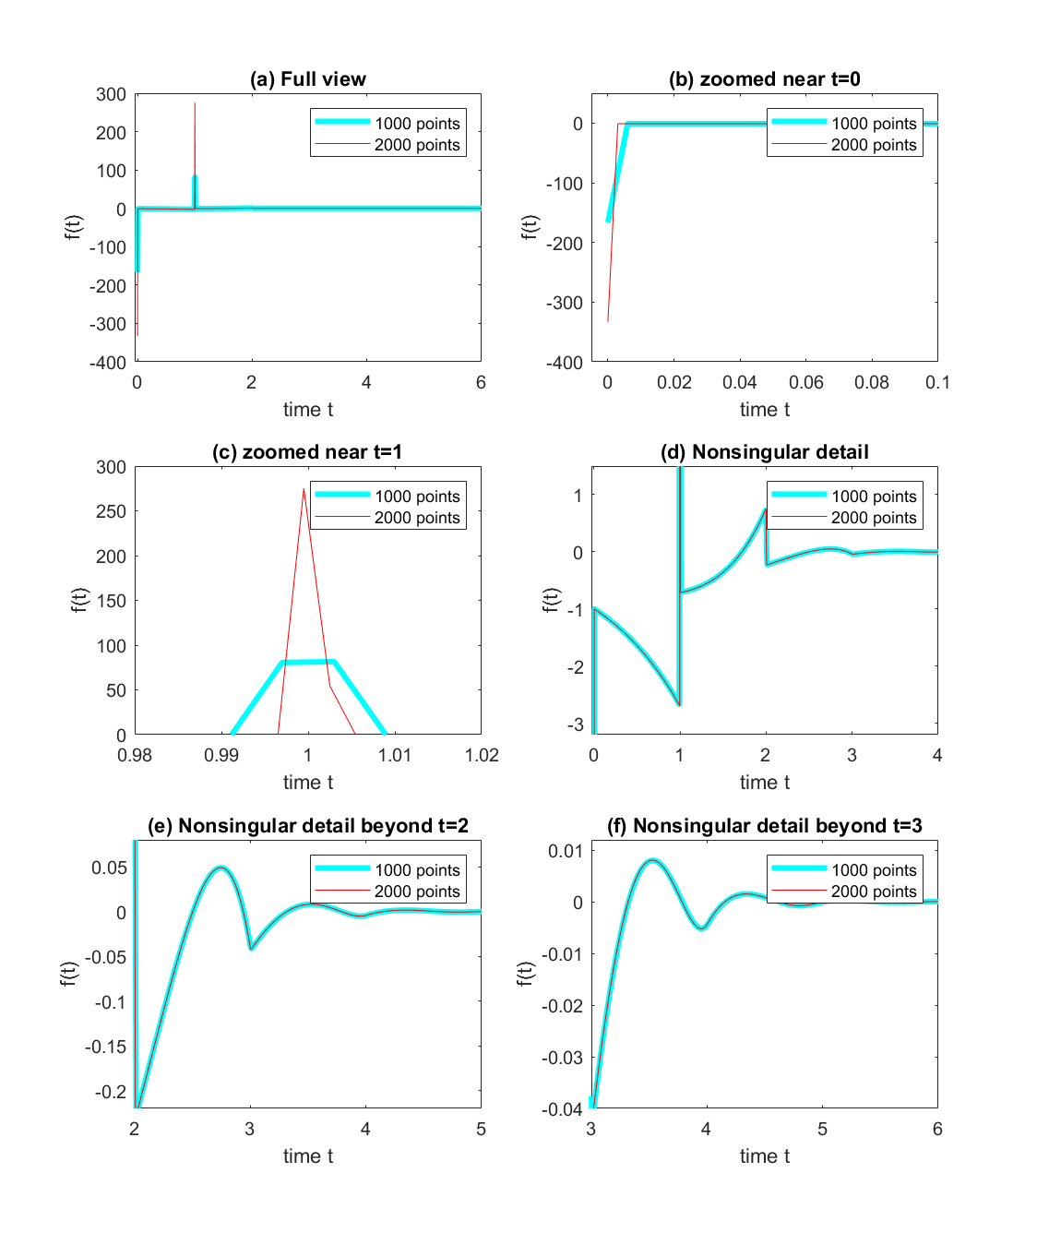

Figure 1. First view of *f(t)*

## 2 Characterization of f

It is clear from figure 1 that there are Dirac delta functions at *t = 0* and *t = 1*. Numerical  
estimates of their strengths suggest both are of unit magnitude. The rest of *f(t)* can be well approximated by piecewise polynomials, on the intervals (0, 1), (1, 2), (2, 3) and soon. We choose to ignore the nonzero values of *f* beyond some large enough *t* (6 in our case). Six such polynomial plots (each of fifth order) are shown in figure 2 (thick cyan: actual value; thin  
dotted blue: polynomial fit). The MATLAB code for generating the plots is given in appendix.

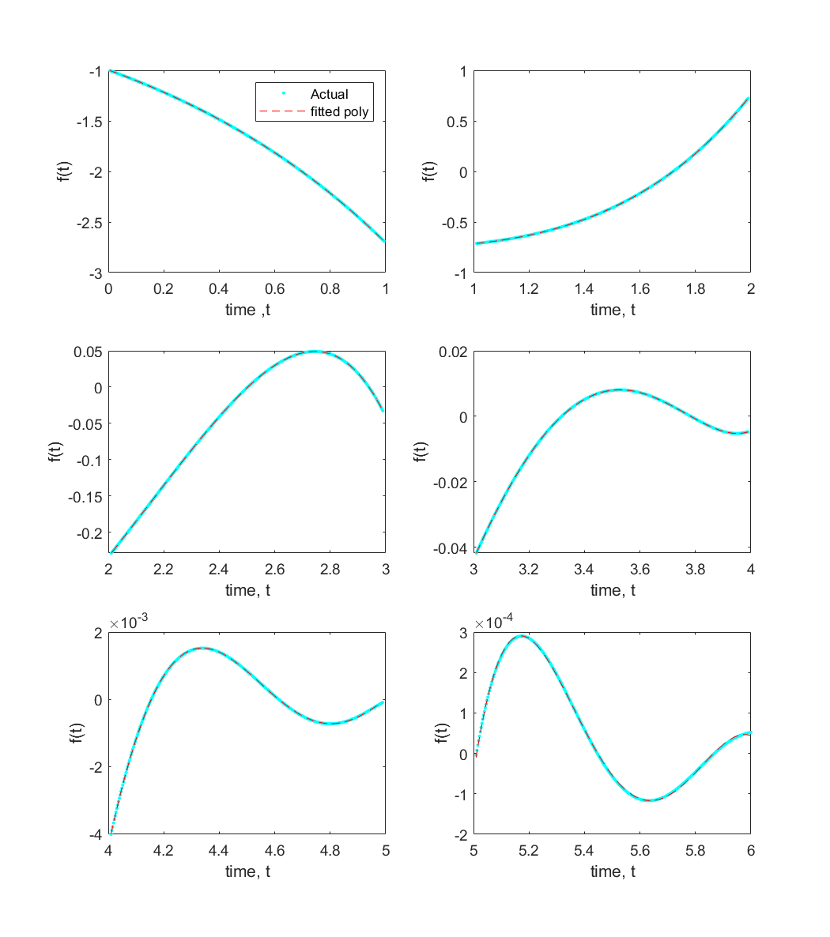

Figure 2. Piecewise polynomial approximations of *f(t)*

The following are the polynomials that are used to approximate the function over the interval [0,6]. $p_{1}\left(t\right)$ is valid for [0,1] and so on.

$$p_{1}\left(t\right)= -0.013710632512548 t^{5} -0.034513828209840t^{4} -0.034513828209840 t^{3} -0.034513828209840 t^{2} -0.034513828209840 t -0.9970047943225$$

$$p_{2}\left(t\right)= 0.065769340324068 t^{5} -0.232119784262183t^{4}+0.669569771778654t^{3} -0.643394878255098t^{2} 0.158376510713934t -0.733276241043621$$

$$p_{3}\left(t\right)= -0.123021612947960 t^{5} +1.180383784418038t^{4} -4.750249222111351t^{3}+10.128655607134766t^{2} -10.962760832339915t+4.229605301968594$$

$$p_{4}\left(t\right)= 0.109117087630768 t^{5} -1.715796441259401 t^{4}+10.746543344419841 t^{3} -33.688193219133893 t^{2}+53.278453268382677 t -34.377956090572617$$

$$p_{5}\left(t\right)= -0.041162143246297 t^{5}+0.909208695112075t^{4} -7.974317295282018t^{3}+34.685597377370854t^{2} -74.748997388063472 t+63.770972556724466$$

$p_{6}\left(t\right)= 0.001089854643174 t^{5} -0.040710458901845{ t}^{4}+0.569633783165602{ t}^{3}-3.820371343283730 t^{2}+12.435310789955334t+-15.833305041499555$

Now we have established our delay differential equation.

## 3 Delay differential equation (DDE)

Our system is (the Dirac delta functions lead to discrete delayed feedback, while the rest of f leads to distributed delayed feedback through integrals)

|  |  |  |
| --- | --- | --- |
|  | $$\dot{x\left(t\right)}= -x\left(t\right)+x\left(t-1\right)+\int_{0}^{1}{p_{1}\left(τ\right)x\left(t-τ\right) dτ}+…+\int_{5}^{6}{p_{6}\left(τ\right)x\left(t-τ\right) dτ}$$ | (2) |

The characteristic roots of the above DDE give, a choice of exponential rates to use for the problem of approximating the original function *x(t).* let’s call them our basis 1 for the approximation.

Now we insert *x(t)= $e^{λt}$* into the DDE, carry out the integrations, and obtain the characteristic equation. We solve this equation in Maple. The characteristic equation obtained is

|  |  |  |
| --- | --- | --- |
|  |  | (3) |
|  |  |  |

The above equation is now solved for λ. It is a transcendental equation with infinitely many roots. But the larger roots of such equation usually follow some discernible pattern, so numerically finding several of them is not really difficult. The first 62 numerical determined roots are shown the figure 3.

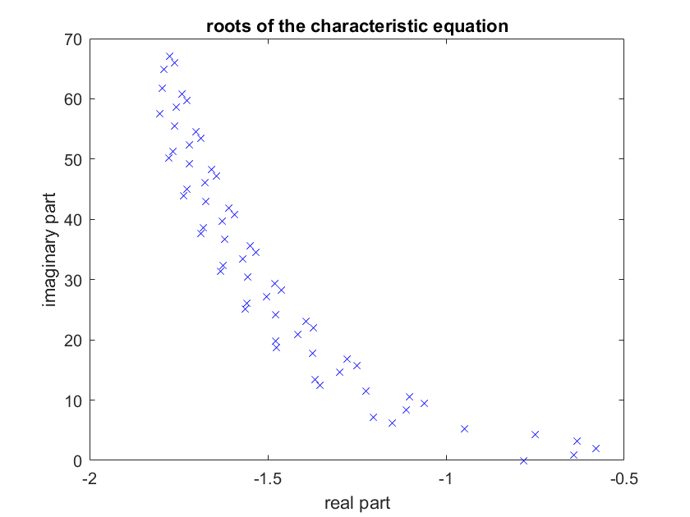

Figure 3. First several roots of the characteristic equation

## **4 Least infinity-norm solution**

If we have an overdetermined system ***Ax = b***, then the least squares (or minimum-error in 2-norm) solution is easy, and given by MATLAB in response to simply *A/ b*. It is less easy, but still standard, to find the solution *x* that minimizes ${\left\|Ax-b\right\|}_{∞}$. We use MATLAB’s linprog to do this. The code for the same is in the appendix.

Using the above infinity-norm minimizing solver, results obtained using 5 roots (i.e., 10 including complex conjugates) are plotted in figure 4. The results obtained using 8 roots are plotted in figure 5. The results obtained using 62 roots are plotted in figure 6.

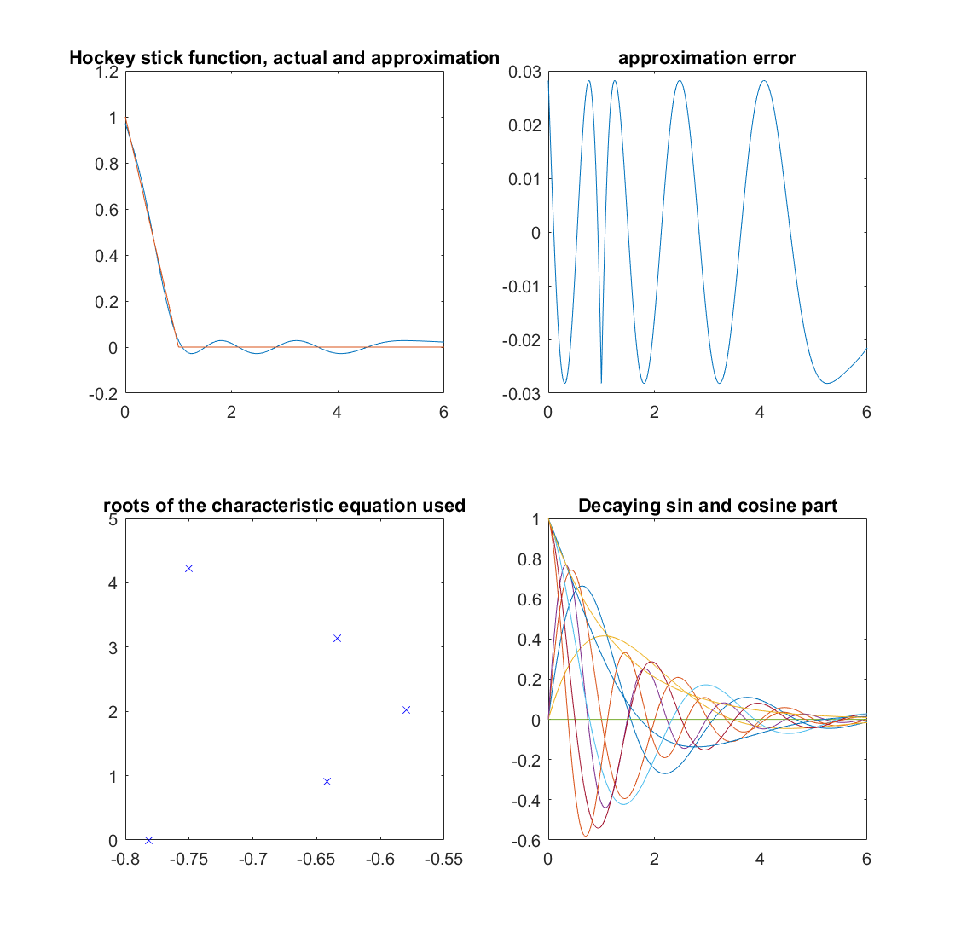

Figure 4. Approximations obtained using 5 x 2 roots

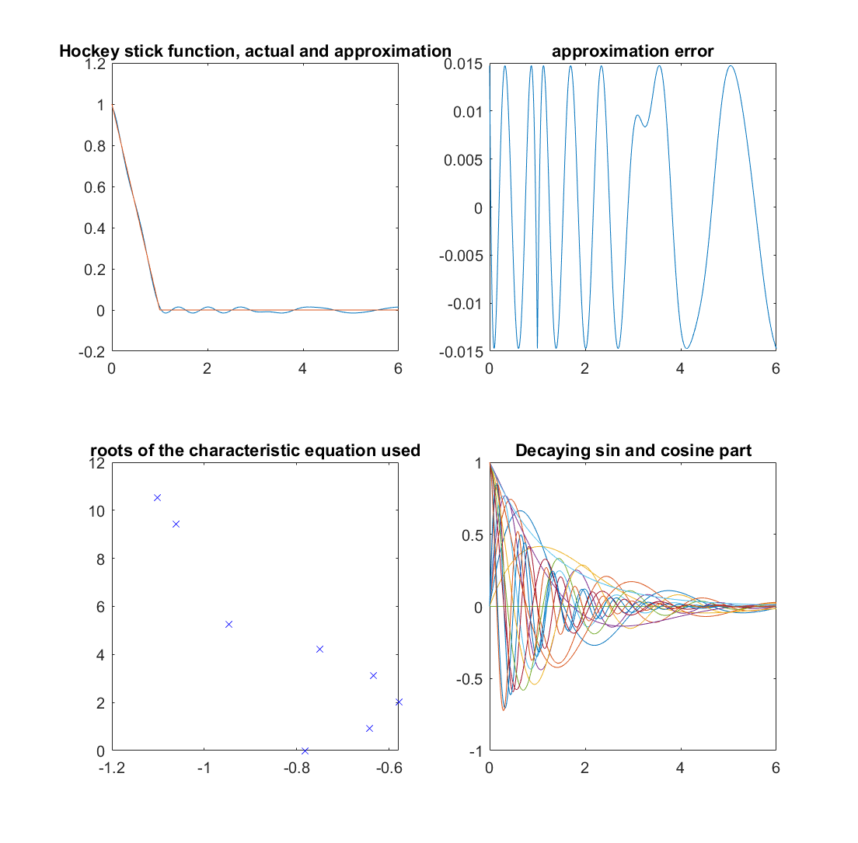

Figure 5. Approximations obtained using 8 x 2 roots

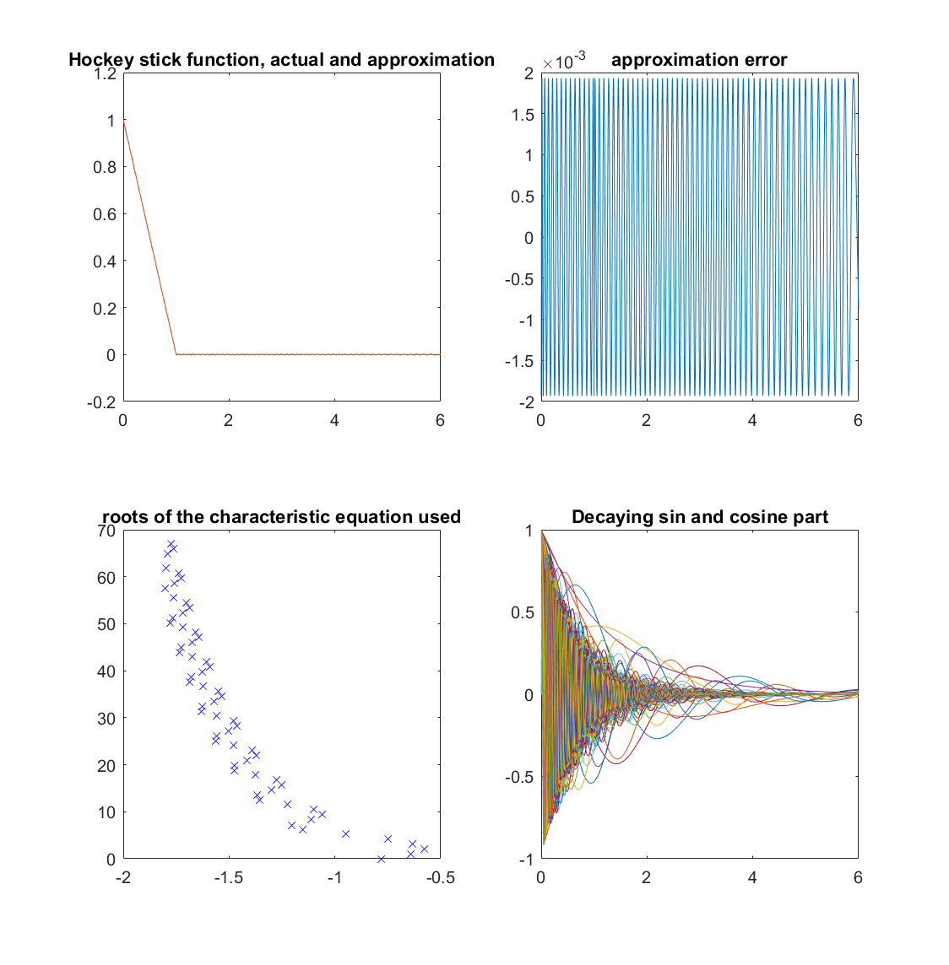

Figure 6. Approximations obtained using 62 x 2 roots

## **5 More functions**

We apply the same method for a few more functions, and we obtain a set of basis. Using these different basis, we shall approximate the same functions and see the differences in approximation and transitions. The functions are approximated from [0,6] and the extrapolated till *t = 19* in order to observe the transitions.

The following function are used to obtain the basis. Lets call the f1, f2, f3 and basis obtained from them be basis1, basis2, and basis3. Furthermore, we also use a simple basis (basis0) obtained from the corresponding DDE: $\dot{x\left(t\right)}= -0.1x\left(t-6\right)$

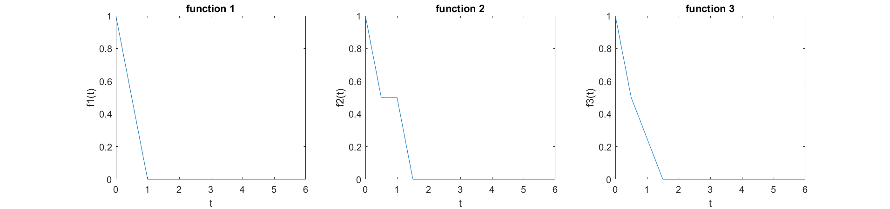

Figure 7. Functions used to form different basis

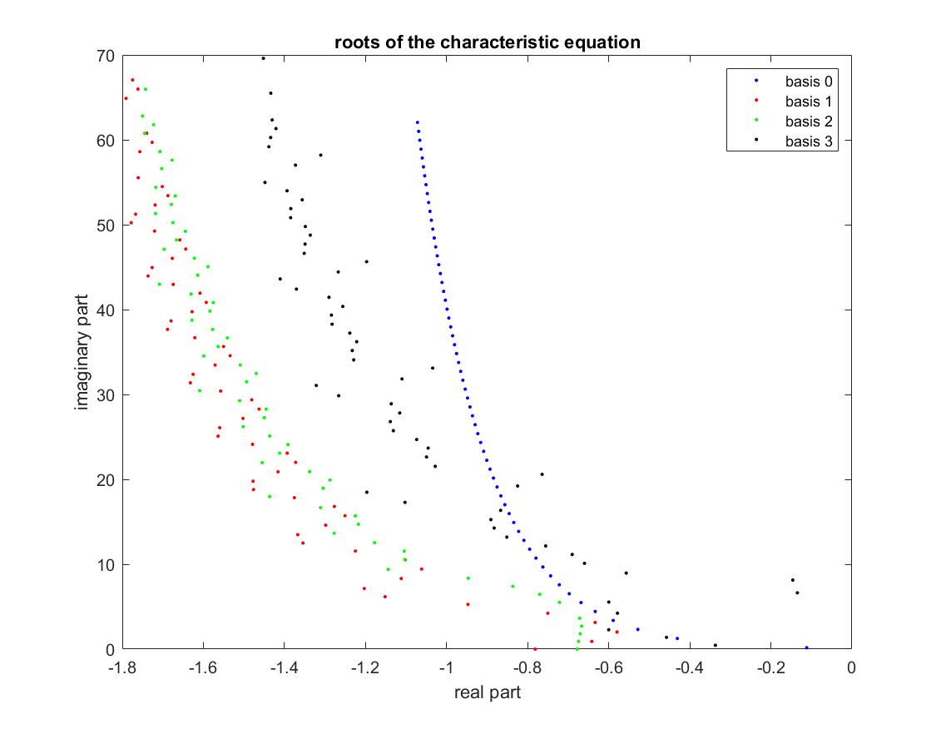

Figure 8. Roots of the different characteristic equations

Using the different basis we approximate the above functions individually to find out the best fit. Approximation of function1 is shown is figure 9. Figure 10 and figure 11 show the approximation of function2 and function 3 respectively.

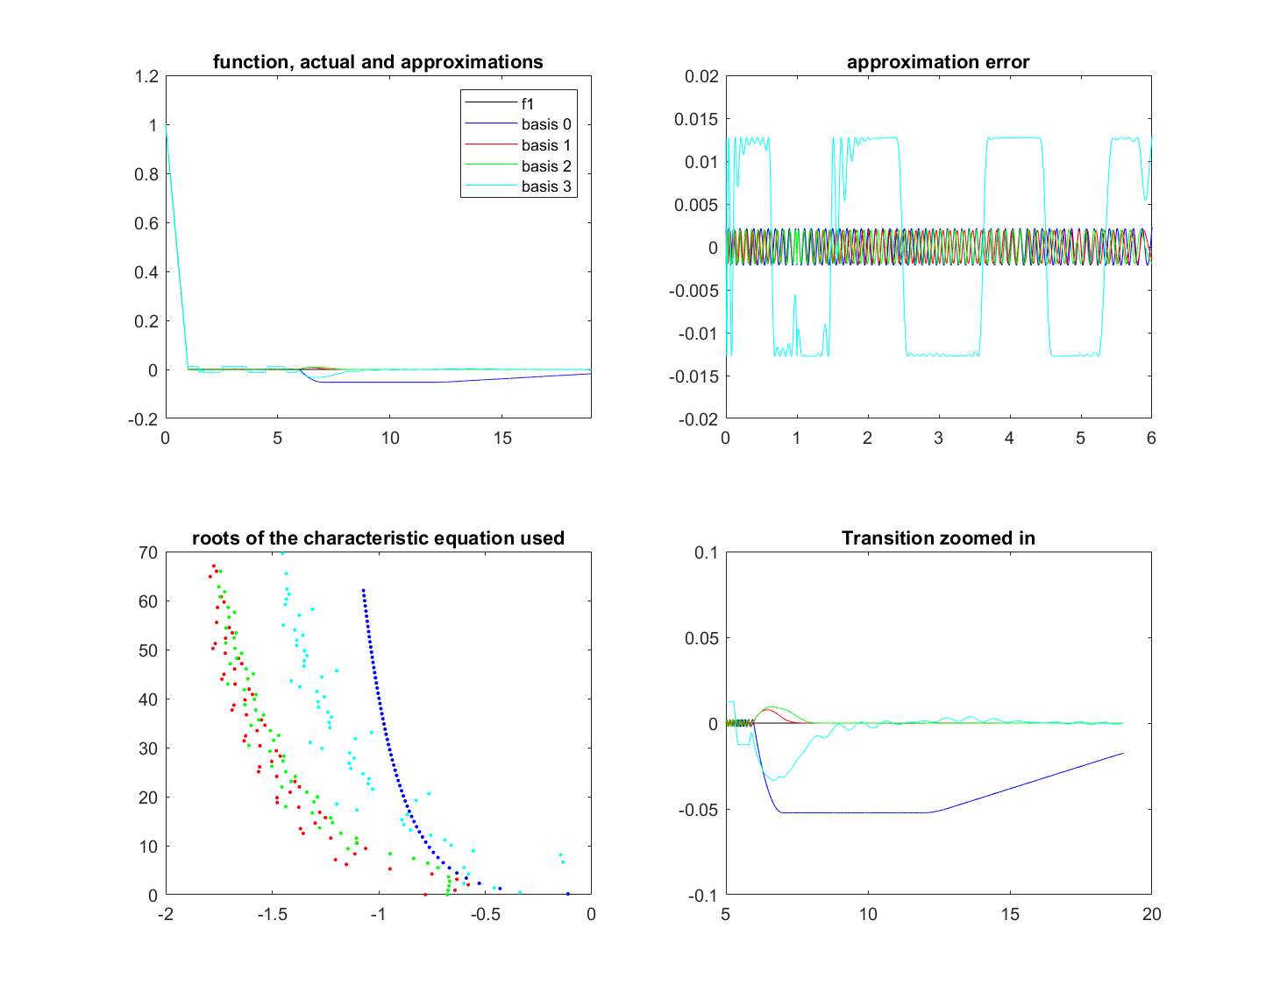

Figure 9. Approximation of function1 using different basis

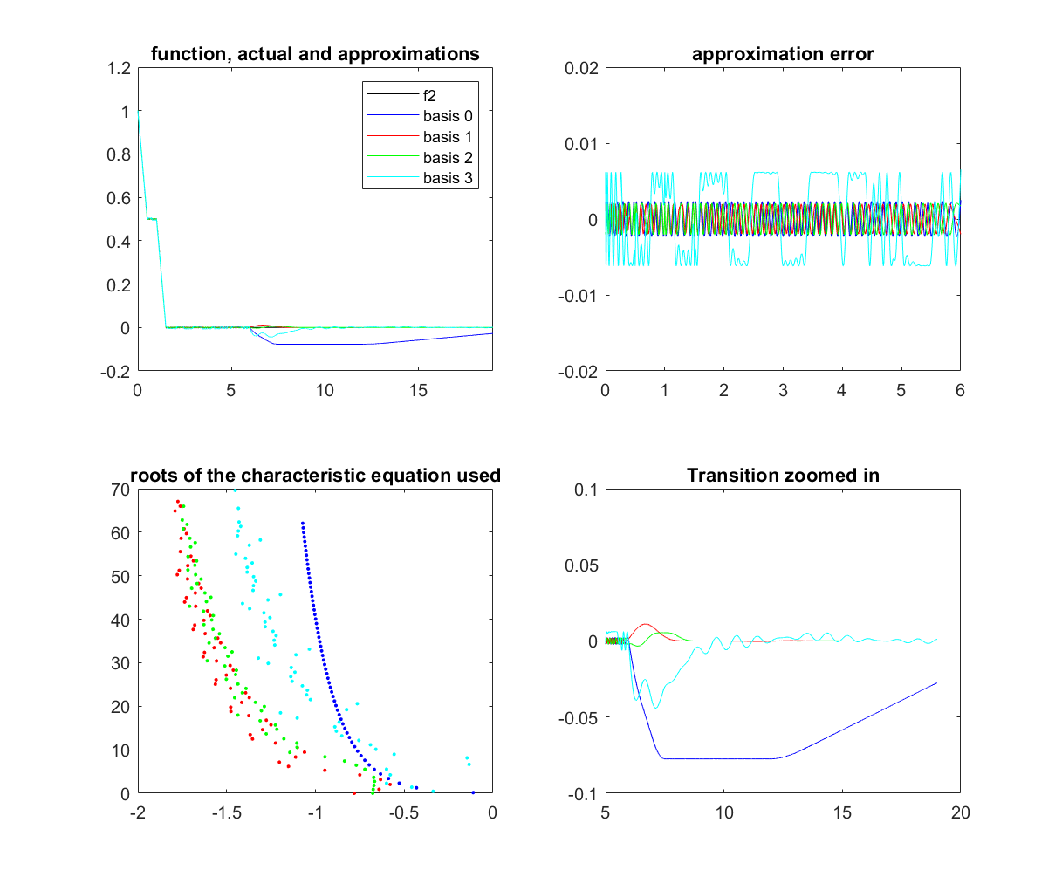

Figure 10. Approximation of function2 using different basis

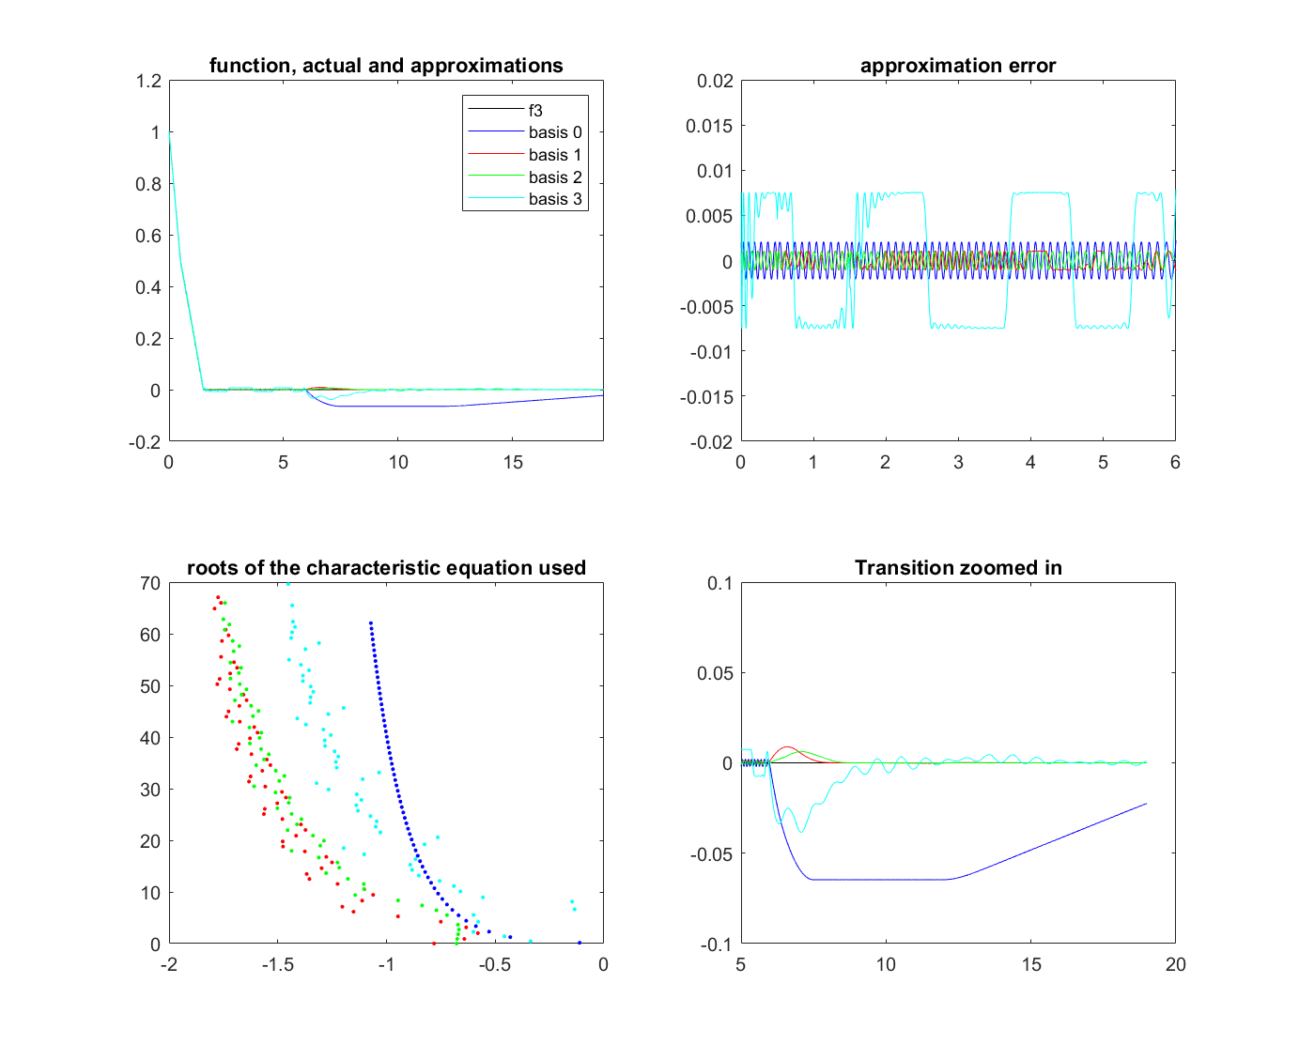Figure 11. Approximation of function3 using different basis